International Information Technologies University

Web Technologies
Report
Front-end part

Submitted by:
Tursynbai Aibolat
Tokmurzin Mukagali
Group: ISCS-1902
Submitted to: Mukazhanov N.K.

Project Requirements (for front-end part)

Group: ISCS-1902
Students:Tursynbai Aibolat, Tokmurzin Mukagali
Topic: Mounteam - SIMPLE MOOD FORMULAS

Structure of the report:
- Title page: We choose topic Mounteam, which organizes available tours for everyone. Motto of Mounteam, “SIMPLE MOOD FORMULAS ". Additional information about this project, it’s real and it’s my friend project, he created Mounteam last year in May, know he works with Instagram and arranges trips to beatyfull places like Charyn, Colsay lake, Butakovka, Gorod Kochevnicov, Issyk lake and other place near with Almaty. You can visit his instagram account:https://www.instagram.com/mounteamkz/. Aibolat and me created from scratch design of this web site and draw it firstly in Tilda.com and then write code with using HTML5, CSS and Bootstrap v4.6. Also, we make our site responsive, so our site will be elegant in any devise, accent is mobile phones, because more than half audience is using mobile phones.

- Main feature is make trips easy and simplify the way of buying tickets for people and so, we have 7 pages, which listed below. Logic of our site is we have the page trips, where person can chose on of them and this trip into basket. For this, he need to Log in or Sign up and then log in. Then using data base the number of tickets for one of this trip will decrease. Also, system admin of site can add content and change design of web site.

- Lists of my pages:
  - Main page
  - Trips page
  - Reviews page
  - Contacts page
  - Basket page
  - Sign in page
  - Sign up page
- Next We want to start with describing main blocks of web site. They are NavBar menu and background image and footer part. We thing it would be more convenient for you.

So, let’s talk about bootstrap, I downloaded Bootstrap v 4.6 with JS, We used only file bootstrap.css and bootstrap.min.js files and connected them with my project. Also, We added my own css file main.css.
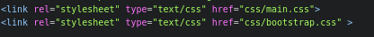

Also added scrips and Java Scrips and Jquery

First of all nav bar, I wrote down nav-menu using Bootstrap and added my own css styles and result here. Main problem here is make nav bar menu responsible, in this case I search from official web site of Bootstrap and use class navbar-toggler button. Also, for links to other pages I used #a and ul/li. With power of Jquery and JavaScrtip it’s magically work. Next I added login button, it’s for registration or log in of user.
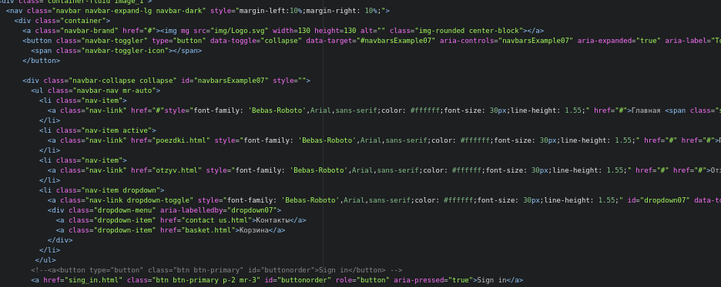
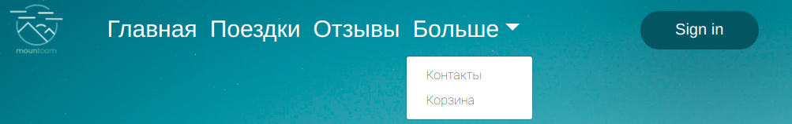

Next, part we used 2 background images, it was quiet difficult. For this we used 2 container-fluid and give them 2 background images with using css code. With power of margin, We give him negative value and put cloud up the second page.And the result, how you can see.
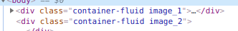
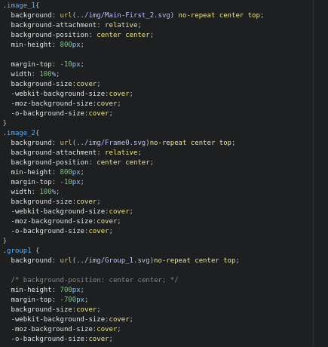

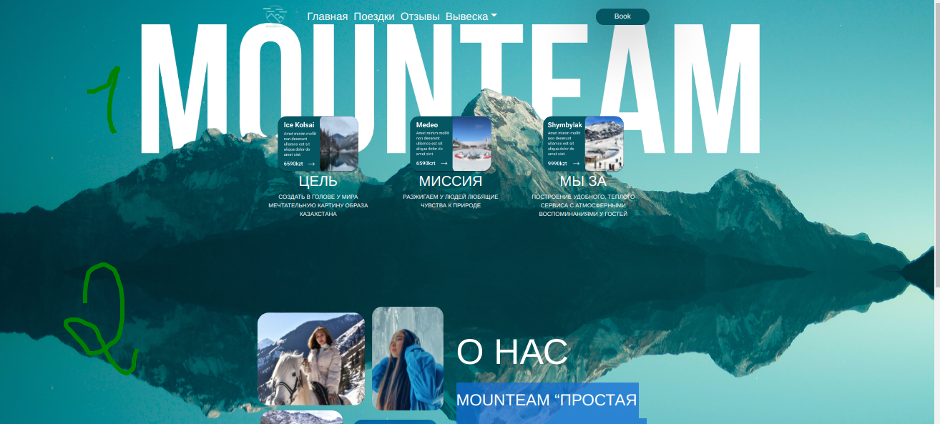

And the last main part is Footer. Footer consist from 2 parts, Footer top and Footer-bottom
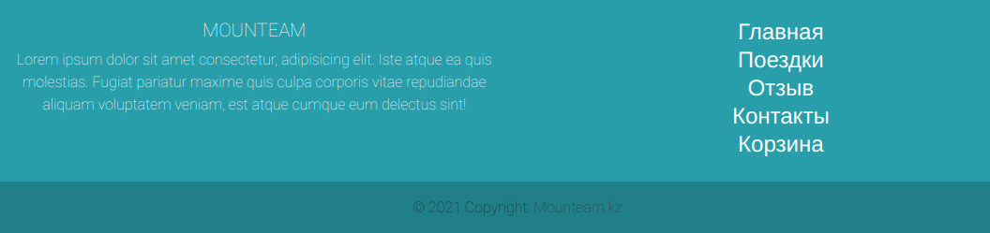
Footer top consist from 2 block, I separate them using rows and col. It consist some helpful info and 3 part is links for other pages. How you can see.

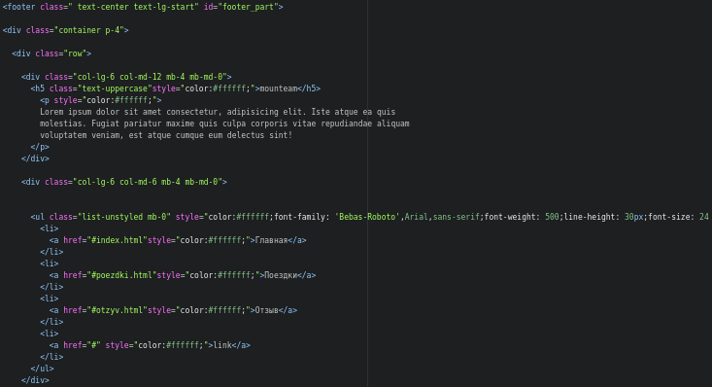
And footer-bottom is quiet simple, it consist from block copyright and how you can see.
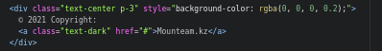

5. Now we are going to stop for body content of every page. In all pages nav-bar and back-image, footer part is equal.
1. Main page(index)
Main page container with 3 container with photo and description, you can see them above. I used display-flex and justify-content for putting then into one line and add my styles.
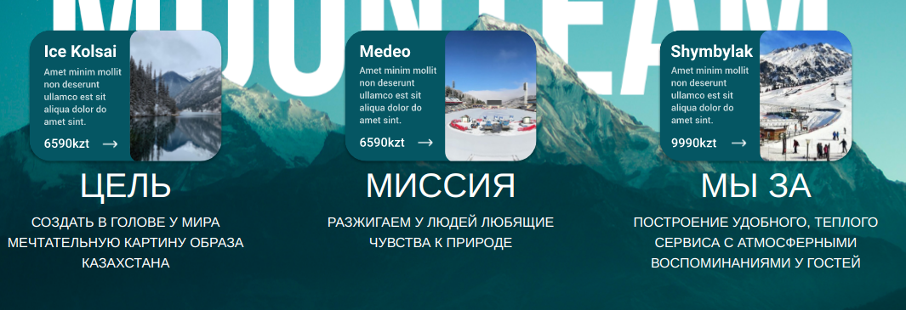

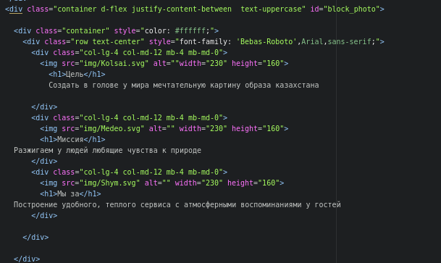
This block consist from 4 image and some Heading. I give them fixed width, and to adaptiveness I used media queries and change display:block and change width.


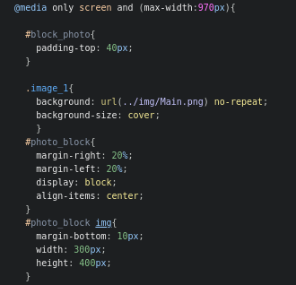
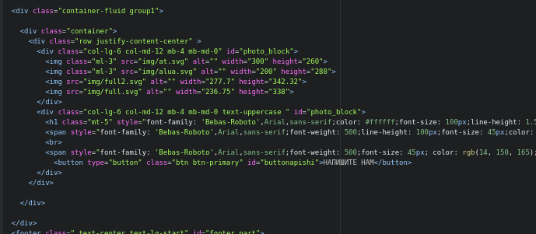

2. Trip page. This page quiet simple, I think that it doesn’t need any description.

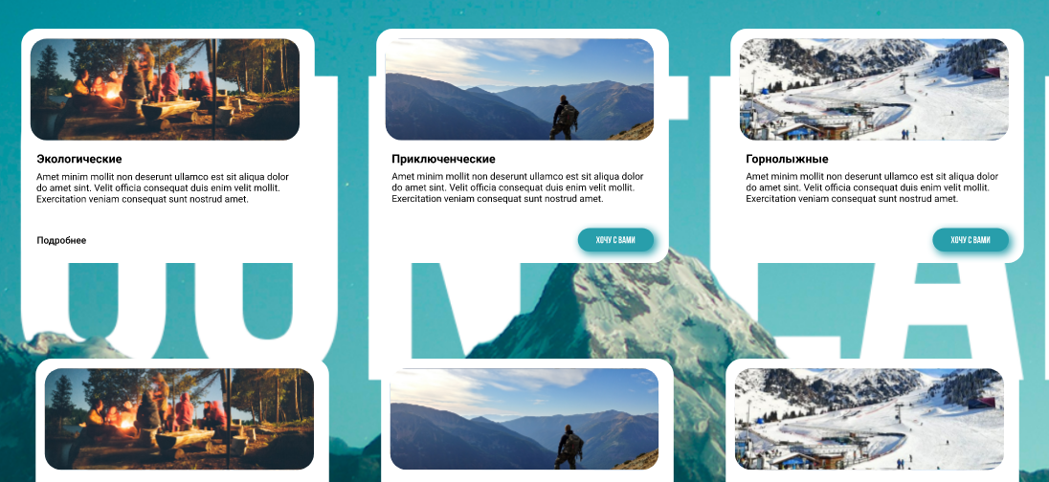
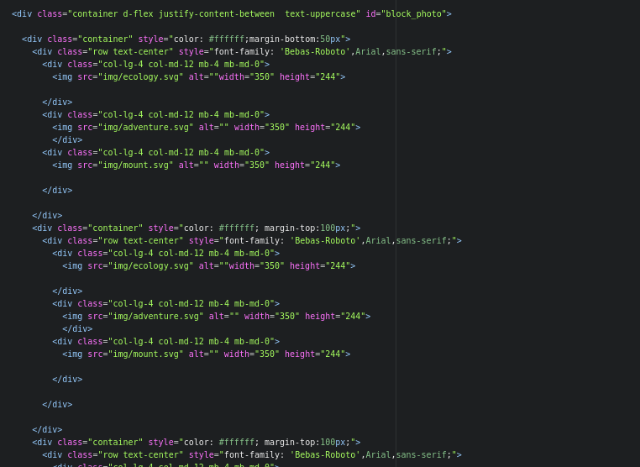

3.Reviews page – this page consist from 2 part: Carousel part, FAQ
There are might information about team member and founder, it would be helpful for users. There might be countless page.
There you can see code, I take template from official web site of Bootstrap and my own style, like font size and etc. I also use d-flex and justify-content-bettween for putting two blocks, how you can see. And make adoptive with media queries, you can see them in file main.css at the end of file.

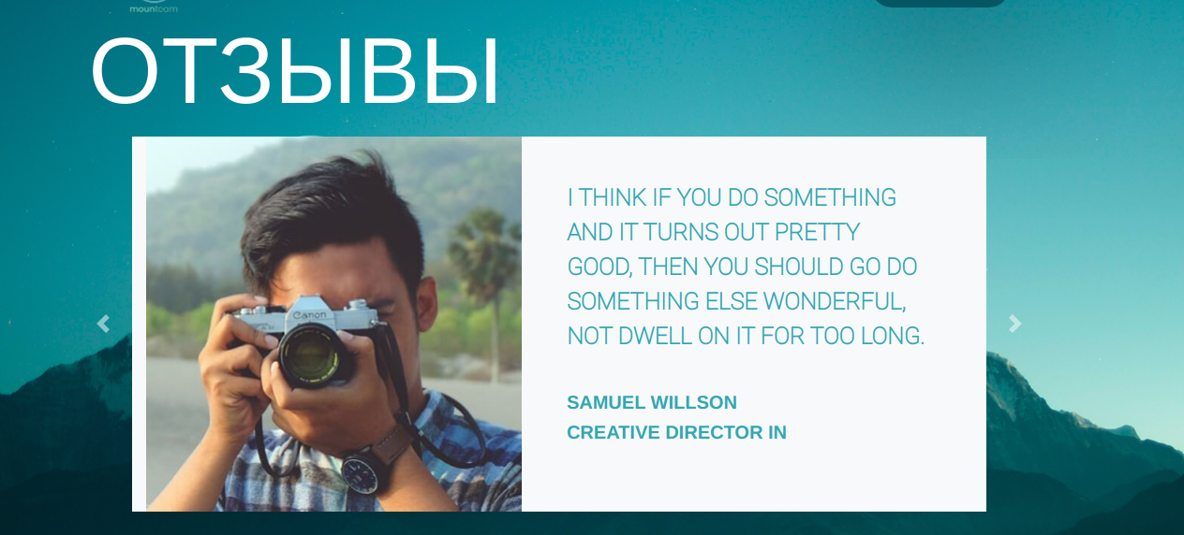
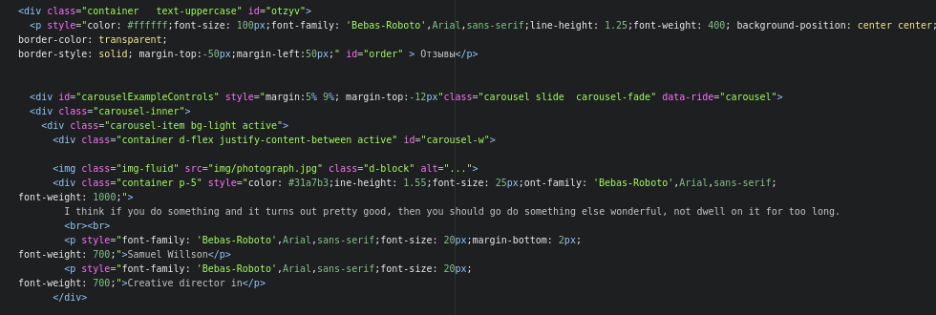
Next is FAQ part, there some questions and when you click it unfolds, how you can see, it works thanks to JavaScrips with collapse of bootstrap and Jquerry.
There you can see code, we also take template from site of Bootstrap
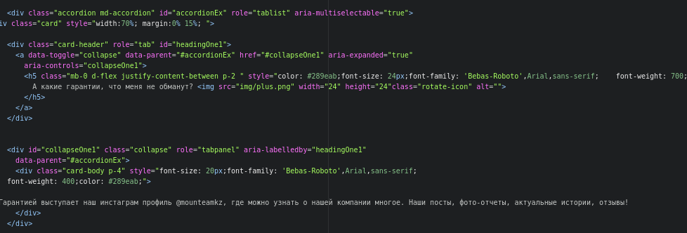
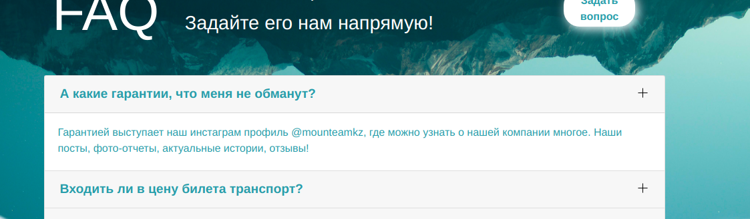
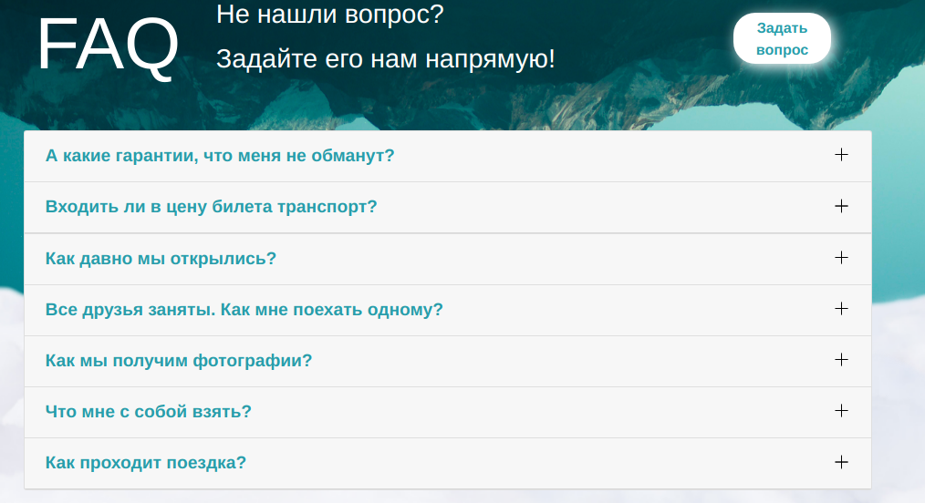

4.Contacts page - the structure of this page is also simple, it consist from one block, there are form with contacts, also there are maps, location of the office.
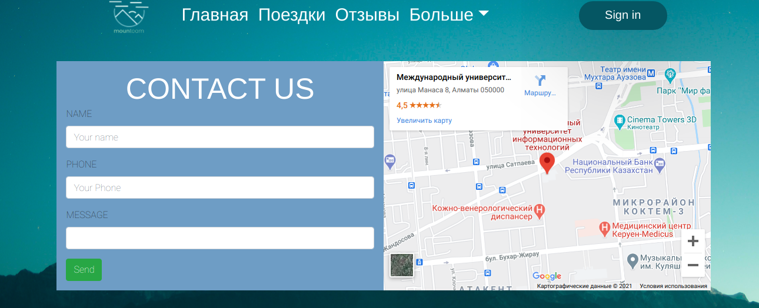
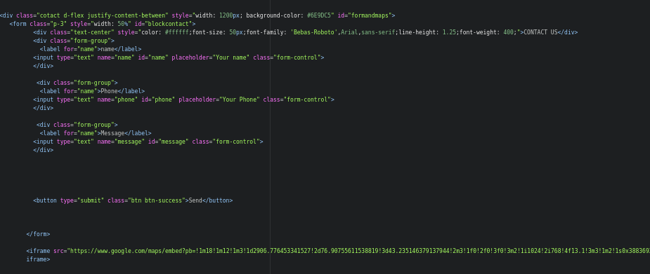
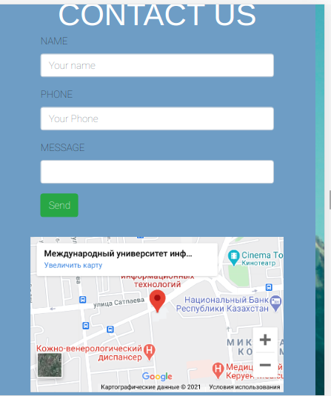
It’s also has a elegant design and fully adoptive for all screens.

Also, there are links for instagram, whatsapp and facebook


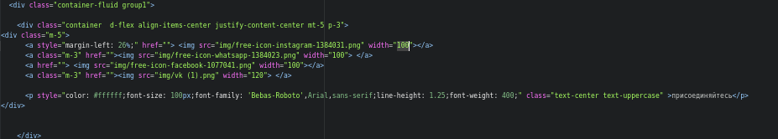

5. Basket page, main feature is adding trips and buy them using payment systems. So, with using php and data base, it will work. Now it’s just model. Also it’s elegant and simple design. We also take l template from official site Bootstrap and add our styles and content. It doesn’t have some difficult code, so I think it’s enough
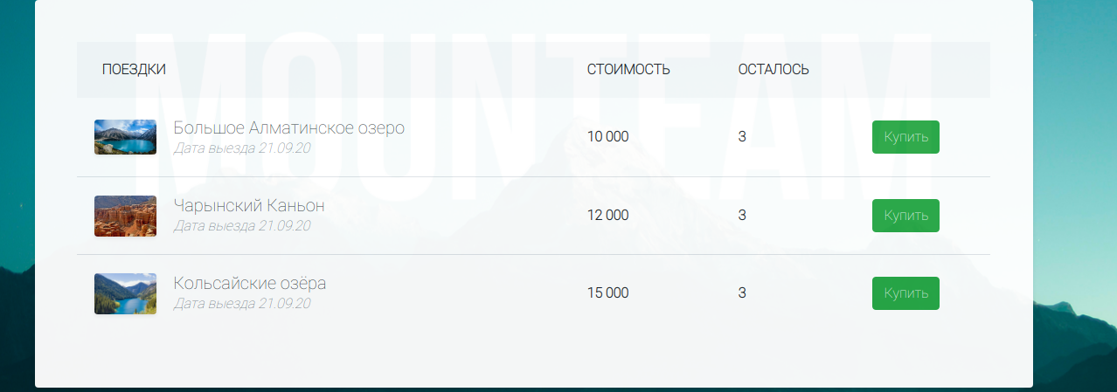

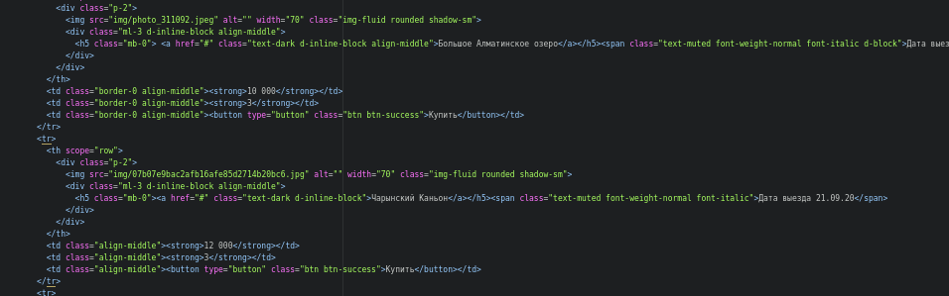

6. Sing in page – is one of beautiful pages and elegant design. Using this page you can log to your account and continue buying process. They are made by using simple forms with input.

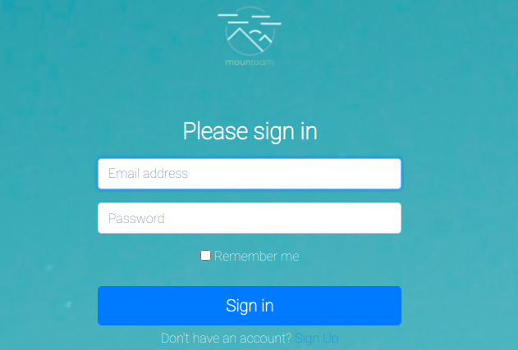
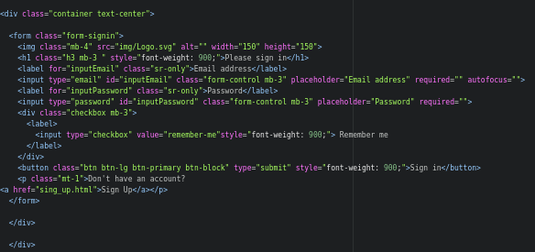

7. Sign up page – if you do not have account, you can create it with this page and then log from sign in page. You need to enter your name, Sure name, email and password. It made by using simple input layouts and with adding my styles.
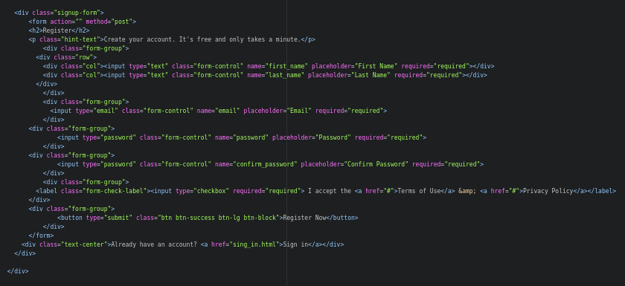
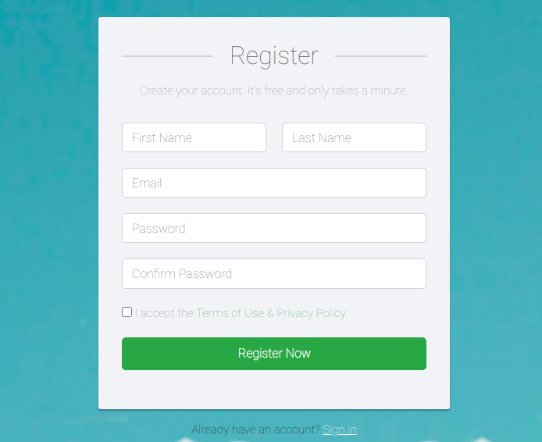

5. Conclusion
So, we finished our project Front end part, I think it is beautiful and has elegant design and functional. During this lab, we improve our writing code skill, working with bootstrap and java script. And about functionality of site might be helpful for users.
6. References
Learning Web Design Fourth Edition, by Jennifer Niederst Robbins Copyright 2012 Littlechair, Inc. All rights reserved. Printed in Canada. (source - dl.iitu.kz)
Сухов К. С89 HTML5 – путеводитель по технологии. – М.: ДМК Пресс, 2013. – 352 с.: ил. (source - dl.iitu.kz)
Bootstrap Tutorial, (source - dl.iitu.kz or https://www.tutorialspoint.com/bootstrap/ )
https://getbootstrap.com/docs/4.6/layout/overview/ - official web page of Bootstrap.
https://bootsnipp.com/ - there you can find templates and other helpful information.

